IACLALS ANNUAL INTERNATIONAL CONFERENCE 2021 (ONLINE)
Co-Hosted By Janaki Devi Memorial College, Delhi University
March 17-20, 2021

“Utopias and Dystopias in Our Times”
With the Covid-19 pandemic slowly creeping over the world in 2020, the Annual IACLALS Conference of 2021 was held from 18 to 20 March in the digital mode on “Utopias and Dystopias in Our Times.” The conference was co-hosted by Janaki Devi Memorial College, University of Delhi. Four days of discussions were held on utopian and dystopian imaginations from across the world in order to ponder over whether we, as humanity, could emerge the better or the worse on the other side of the pandemic.
An inspiring keynote address was delivered on the eve of the Conference by Professor Suman Gupta, The Open University, UK, wherein he proposed a prognosis about considering utopias and dystopias as inherently fragmented by nature, with the world not offering the easy comfort of either-or options.

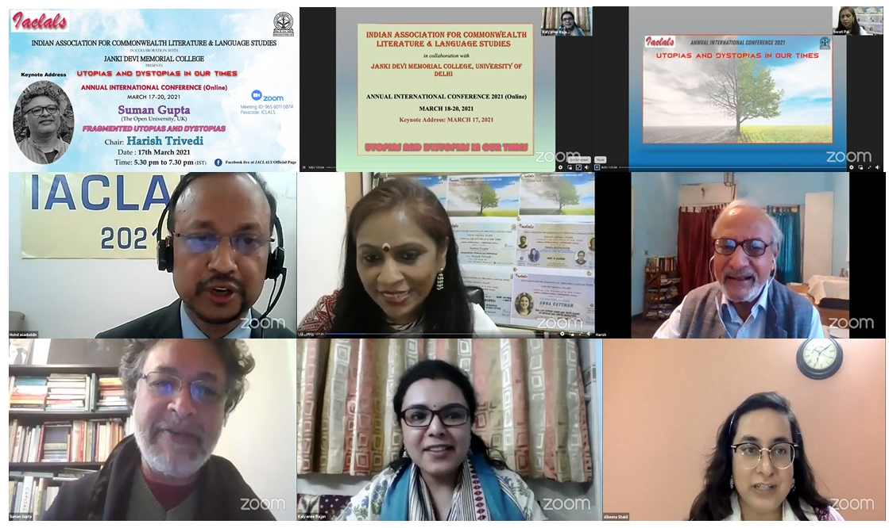

Sessions during the three day conference were organized around the following sub-themes: post- and trans humanism, ecocides or ecotopias, anti-utopias or anti-anti-utopias utopias of Indian modernities, techno-dystopias, dystopias of children and young adults, rethinking generic links with science fiction, fantasy and speculative fiction, utopias in elsewhere places but also in intermediate other places like Foucault’s heterotopias, dystopian writings by women, feminist & queer utopias and ustopias, postcolonial dystopias, and pandemic fictions.

In all, fifty-six papers presenters of this online conference navigated very tight and demanding schedules of the webinar mode along with the vagaries of technology to offer a lot of food for thought with brevity. Like in all IACLALS conferences, a wide array of print, graphic and video texts from India and abroad, in English, in translation and in many Indian languages as well as issues of theory were under discussion by a mix of early, mid to late career scholars.

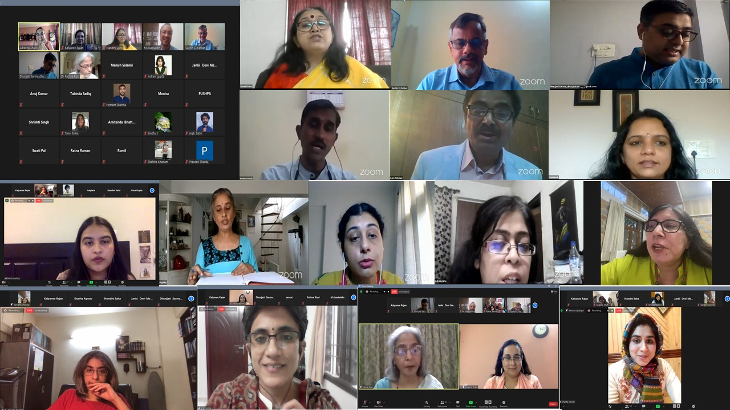

Holding a virtual/online conference was a rare occasion to rekindle connections with many long associated members, some of whom graciously agreed to chair sessions and add value to the conference and forge new connections. The following scholars added to the conference discussion by agreeing to be session chairs, namely, Professor Harish Trivedi and Professor GJV Prasad, both former IACLALS Chairs, Prof. Supriya Choudhuri, Professors Sachin C. Ketkar, M. Asim Siddiqui, Vibha S. Chauhan, Angelie Multani, Somdatta Mandal, Meenakshi Bharat, Priyanka Tripathi, Ranu Uniyal, Sukrita Paul Kumar, T Vijaykumar, Rukmini Bhaya Nair, Meenakshi Pawha and Subhendu Mund.

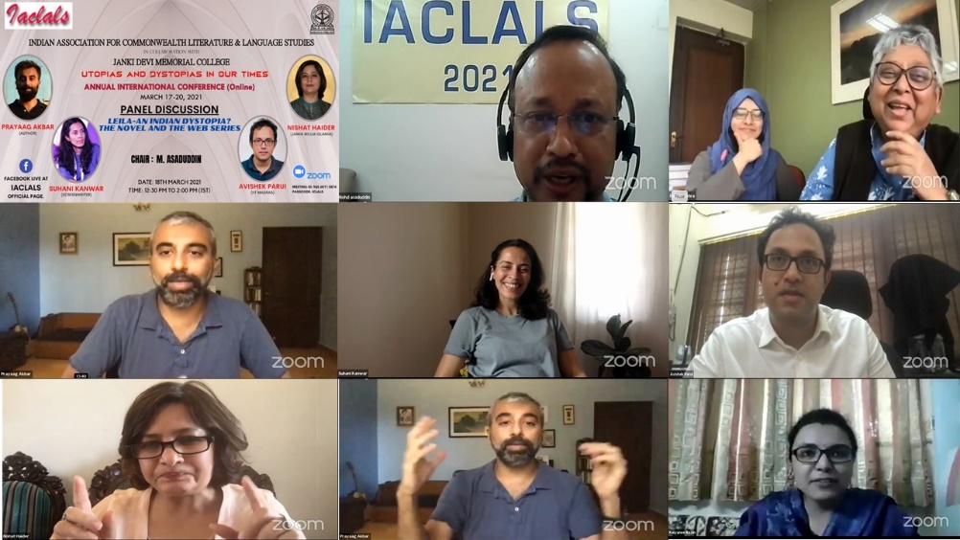

A special panel discussion moderated by Prof. M. Asaduddin was held on ‘Leila: An Indian Dystopia? The novel and The Web Series’ with author Prayaag Akbar and screenwriter Suhani Kanwar engaging in a very vibrant and lively discussion with Prof. Nishat Haider, Jamia Millia Islamia and Dr. Avishek Parui, IIT Madras.

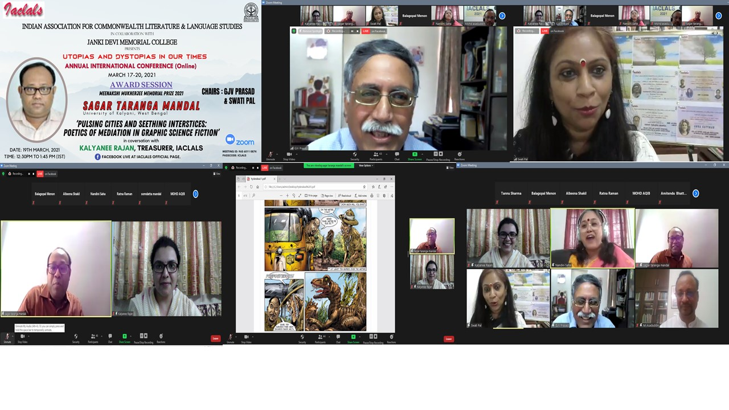

Enthusiastic entries were received for the Meenakshi Mukherjee Prize and the C D Narasimhaiah Prize for best paper published in the block of the past two years by an IACLALS member and the best paper presented at the conference. Judges and jury who invested their invaluable time and careful attention to the papers and presentation included Professors Asim Siddiqui and Snehal Sanghvi, Professors Malashri Lal, Suman Gupta, Sukrita Paul Kumar, Nishat Zaidi, Margaret L. Pachuau and Sumanyu Satpathy.

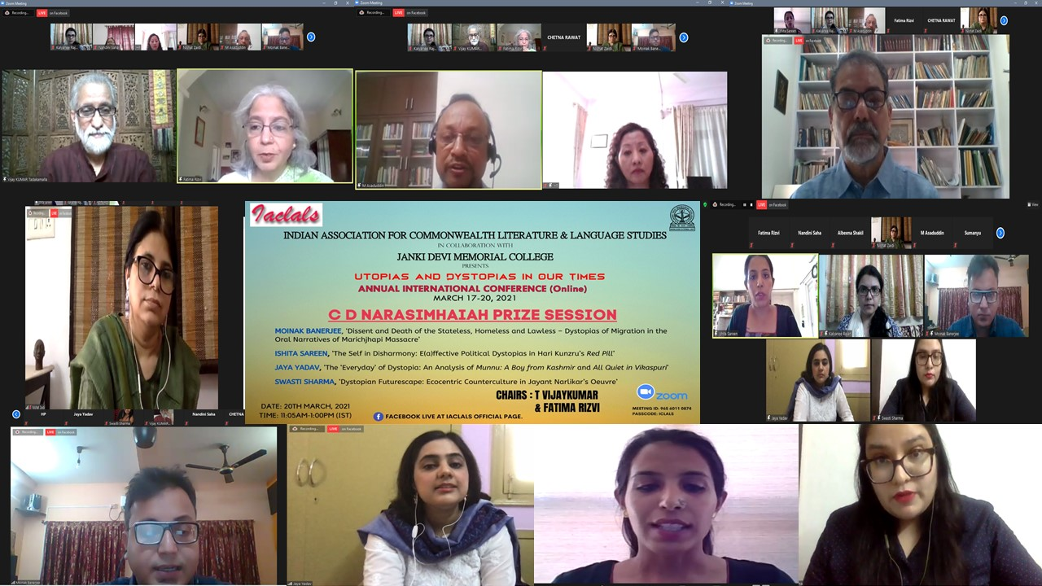

Sagar Taranga Mandal was the winner of the prestigious MMM Prize and Moinak Banerjee was the winner of the CDN Prize, both outstanding winners of the prizes. Ms. Kalyanee Rajan, Treasurer (IACLALS) engaged in a discussion with Mr. Sagar Taranga Mandal on his paper, while Mr. Moinak Banerjee emerged the winner from among the four shortlisted finalists that also included Ishita Sareen, Jaya Yadav and Swasti Sharma. Professors Swati Pal and Fatima Rizvi from the IACLALS Board coordinated the overall prizes.

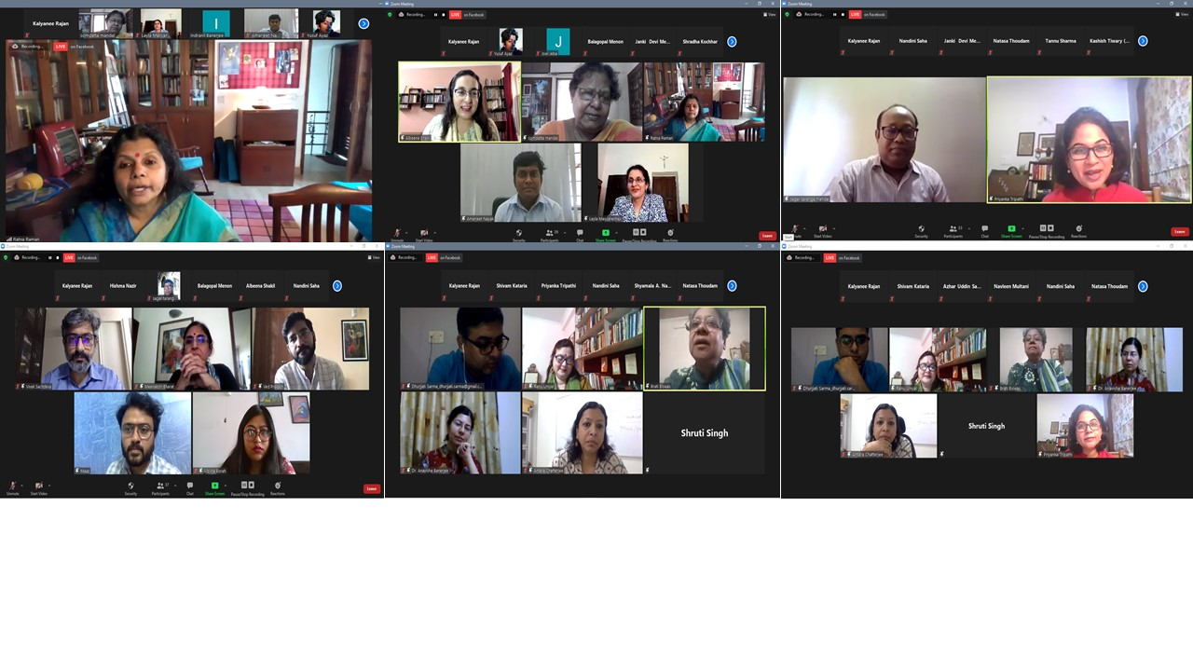

A special book release session was held for IACLALS members who had authored, translated and edited books that were published since the last conference during the pandemic year. Books by the following were released during the conference, namely, Prof. Shyamala A. Narayan, Prof. GJV Prasad, Dr. Nilanjana Mukherjee, Professors M. Sridhar & Alladi Uma, Prof. Mini Chandran, Dr. Sreenath V.S., Dr. Anandita Pan, Dr. Madhumita Chakraborty, Mr. Anas Tabraiz, Dr. Sanjib Kumar Baishya, Dr. Hari Prasad, Dr. Prem Kumari Srivastava and Ms. Mona Sinha, Dr. Gitanjali Chawla and Dr. Sangeeta Mittal, and Dr. Navleen Multani. Brief glimpses were offered into their scholarship and creative work.
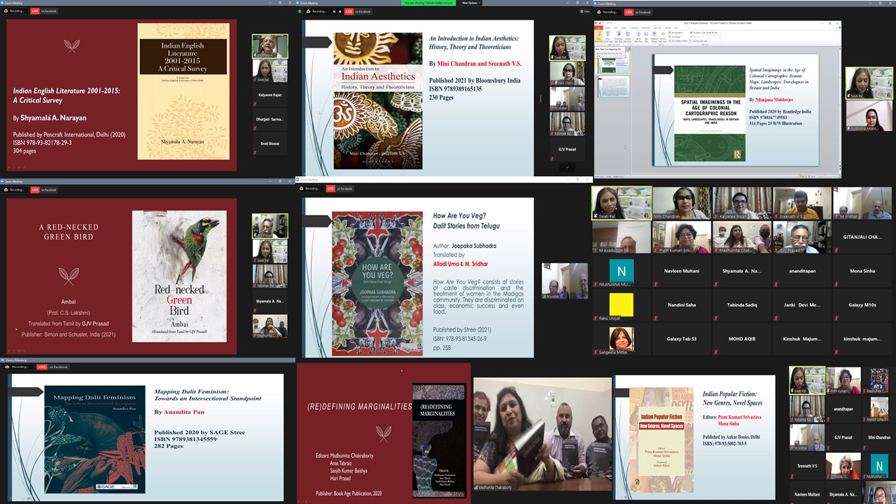

The befitting Valedictory Address was delivered by Professor Anna Guttman, Chair ACLALS and Professor, Lakehead University, Canada, on ‘Real Life Fiction: Genre and Truth Claims in Popular Call Centre Narratives’ connecting many sub-themes of the conference to contemporary Indian fictions navigating utopian and dystopian themes.
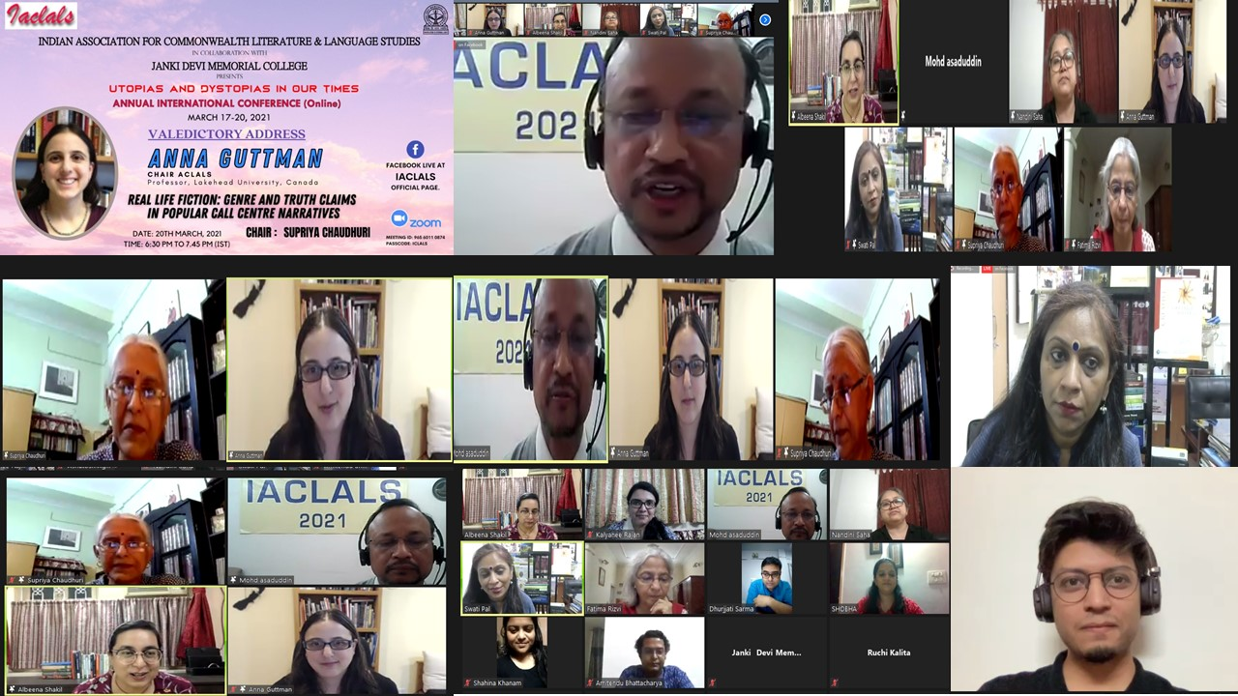

Along with the entire IACLALS Board comprising of Professor M. Asaduddin, Chair IACLALS, Jamia Millia Islamia, Prof. Swati Pal, Vice Chair and Principal, Janki Devi Memorial College, Prof. Albeena Shakil, Secretary, from OP Jindal Global University, Ms. Kalyanee Rajan Treasurer, from University of Delhi, regional representatives, namely, Prof. Nandini Saha, from Jadavpur University, Kolkata. Dr. Fatima Rizvi, from the University of Lucknow, Dr. M. Shobha, from Bangalore University, Dr. Dhurjjati Sarma, from Gauhati University, Dr. Amitendu Bhattacharya, from BITS Pilani, Goa, Dr. Shaifta Ayoub, from Srinagar, a team of twenty-four volunteers from across the country ranging from faculty members, research scholars to graduate and undergraduate students made the successful and organization of the conference possible. While initially, the CFP of the conference was floated with some trepidation because some leading scholars of Utopias and Dystopias hold the view that there are no significant utopias or dystopias outside of the western world. Yet, the enthusiastic response to our CFP and the wide set of papers presented in the conference made us seriously ponder whether in India we are already, always negotiating so many socio-economic-political imperfections in such a deeply stratified and diverse society so as to neither get enthralled by seeking perfections in the form of collective or shared Utopias, nor as a corollary be prone to dystopian thinking either, or whether for us with decolonization delivering both independence and the painful blow of partition together, our utopian impulse has since been on a long road to the more recent surge in retro-topias that seek to reach or restore our lost or stolen futures through amnesia and contested recollections of the past.

While the conference did not deliver a final verdict on this debate, enough threads were generated to continue this conversation in productive ways in the days to come.

Albeena Shakil
Secretary, IACLALS
Professor of English, Jindal Global Law School,
O P Jindal Global University, Sonipat, Haryana.

***

